# Book Bank process

*USECASE DIAGRAM*

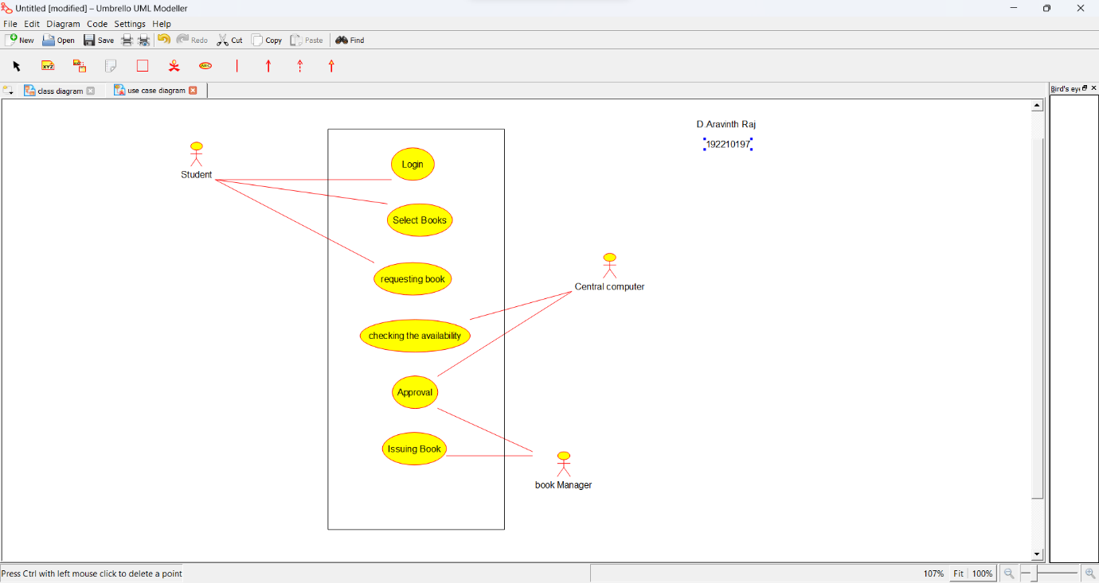

*CLASS DIAGRAM*

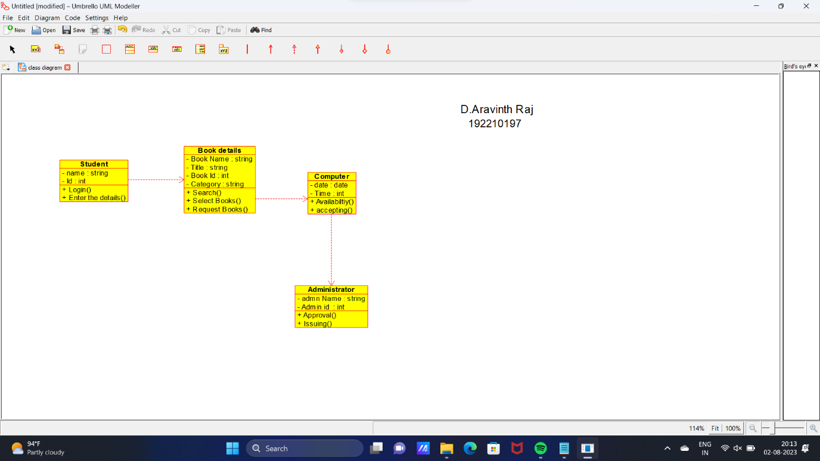

*ACTIVITY DIAGRAM*

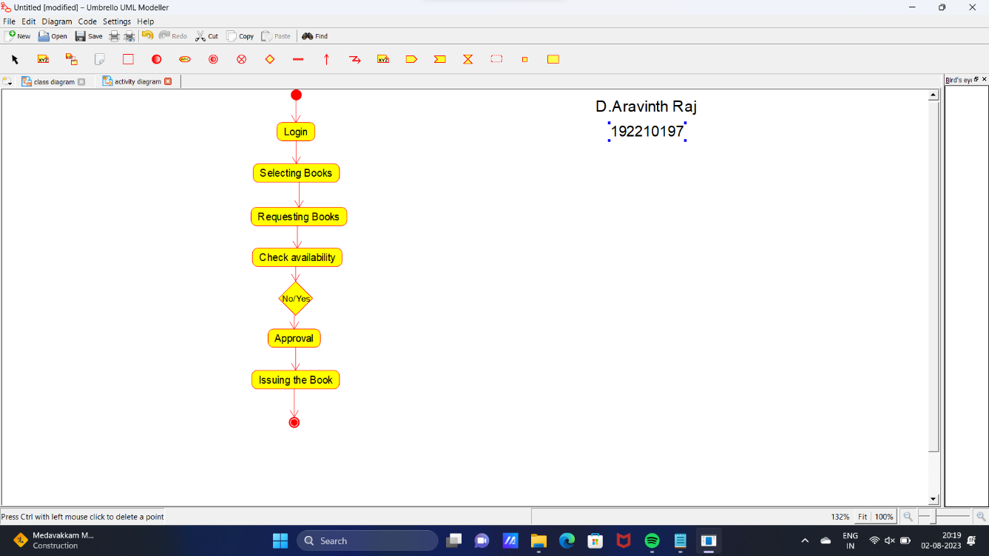

*STATE DIAGRAM*

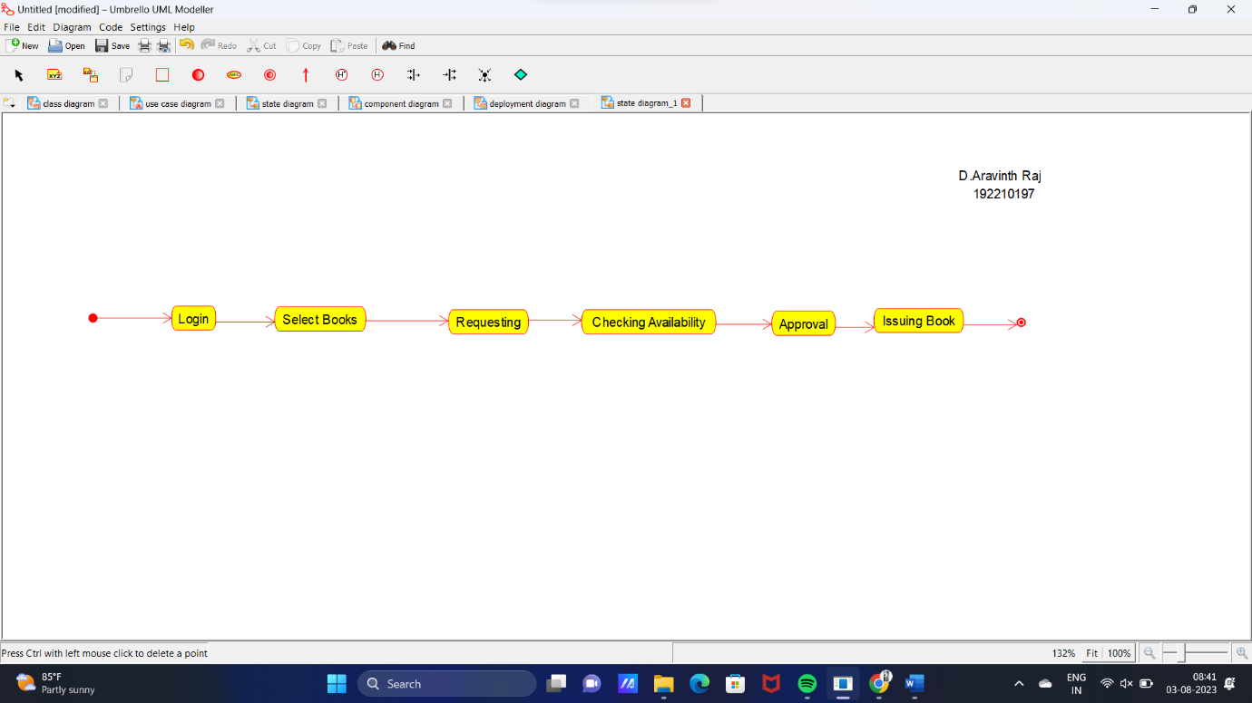

*SEQUENCE DIAGRAM*

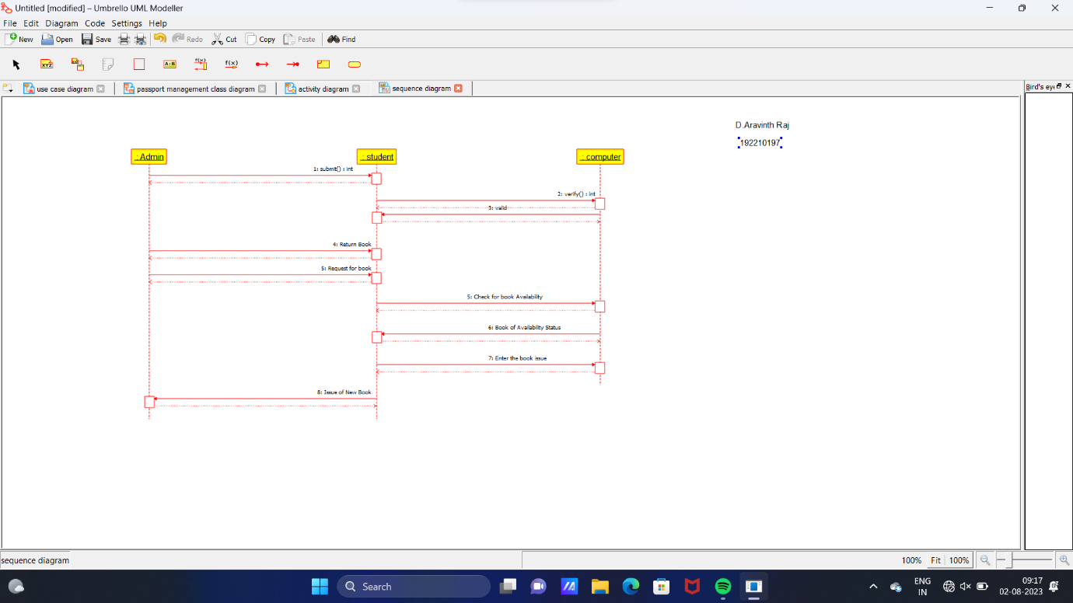

*COMMUNICATION DIAGRAM*

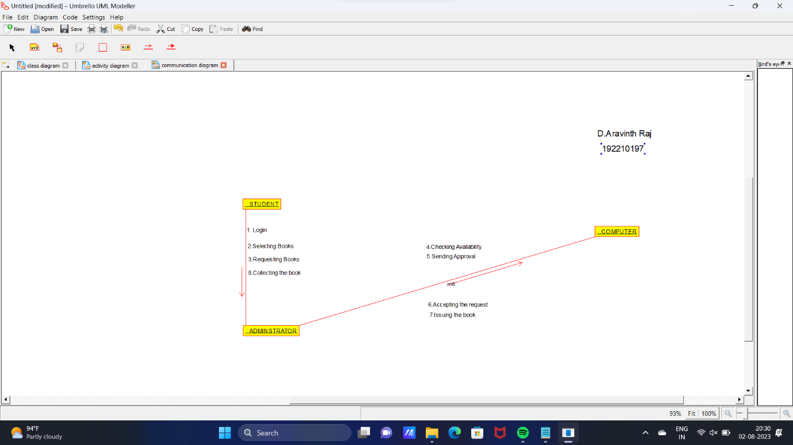

*DEPLOYMENT DIAGRAM*

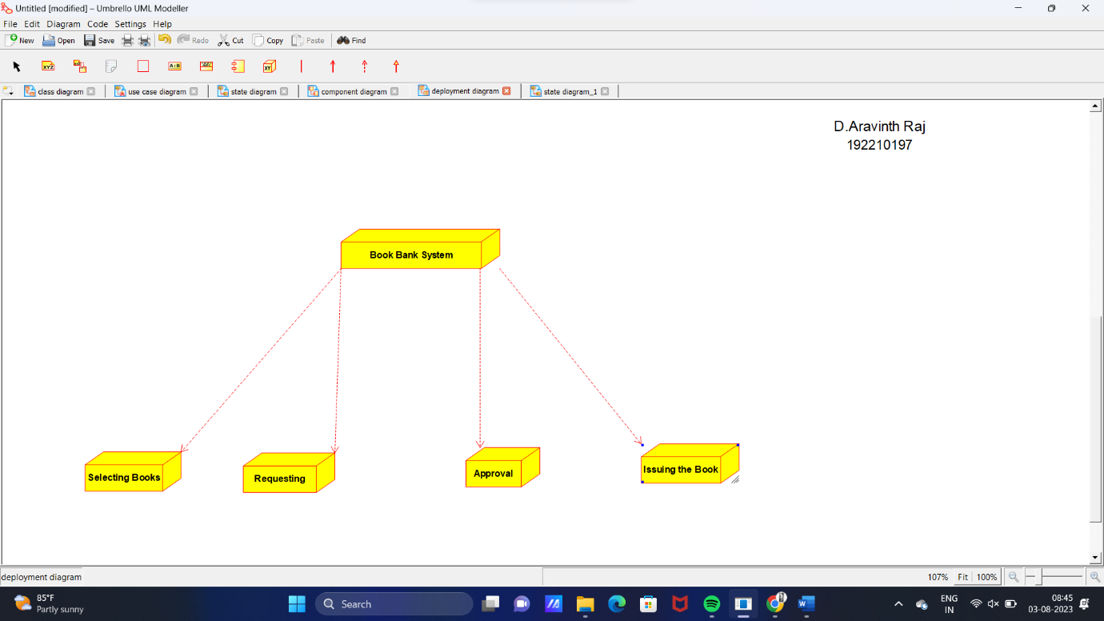

*COMPONENT DIAGRAM*

**